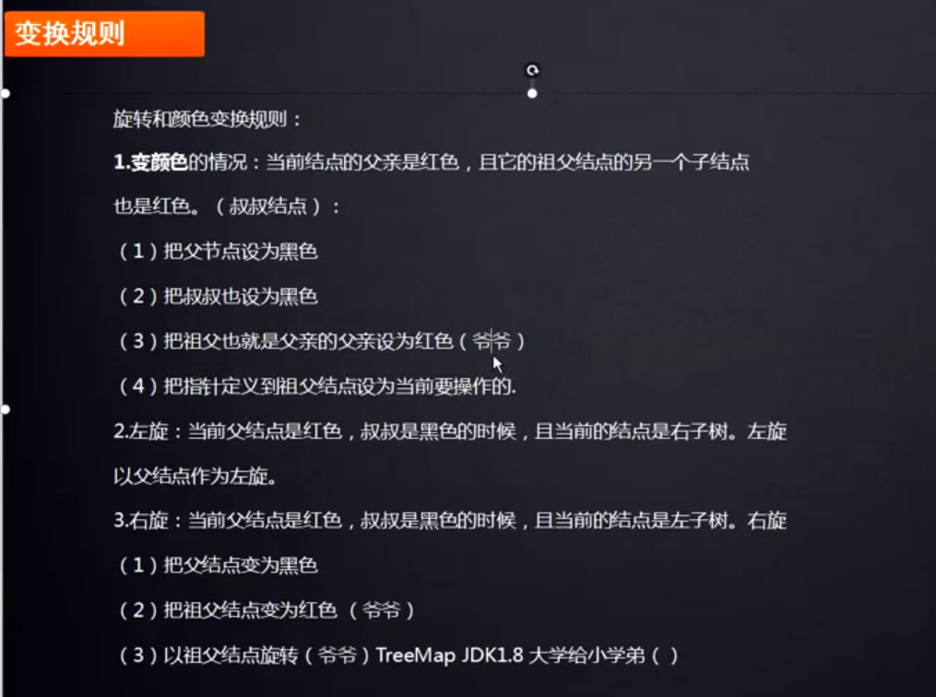

https://blog.csdn.net/qq_26803795/article/details/104608838

